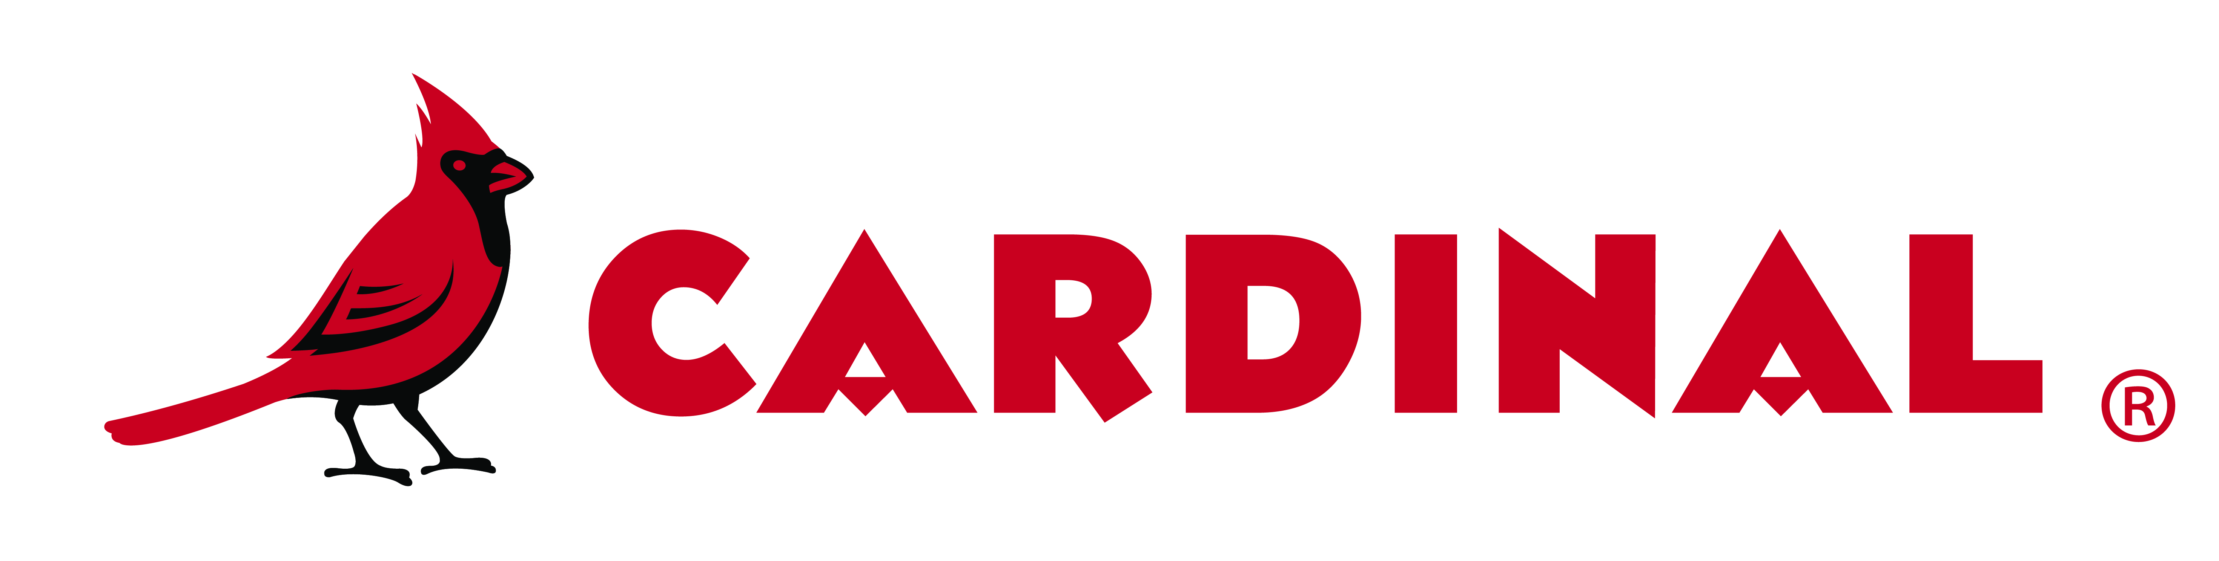

As little as fifty pounds of polyester TGIC, color matched powder made just for your project.

➔Options Available:
- Standard Finish - Smooth finishes available in 20 to 90 gloss and two textured finishes.
- Premium Finish - Low gloss, high chroma.
- Colors Available - Most colors with the exception of metallic, hammertone, fluorescent, multi-colored, and wrinkle powders.
- Quantities of 50 lbs. to 200 lbs. are covered in the Cardinal Xpress Program.
- We will match your color within a Delta E of 1.0 and the gloss will be within +/- 5 units at 60°.
- Pricing includes ground shipping to your location within the Continental United States.

Step 1 - Fill out the boxes below
Customer Name | Customer Account # | Issue Date
Customer P.O.# | Project/Color Name | Date Required
Step 2 – Select Finish | Step 3 – Select Quantity / Pricing
Standard Finish Type | Standard Pricing | Premium Pricing
Smooth Texture  X009 X008 X041  X007 X006 X043  X005 X004 Match Std.  X003 X002 Gloss/Text | Quantity & Pricing  50 lb. $16.00/lb.  100 lb. $15.00/lb.  150 lb. $14.00/lb.  200 lb. $13.00/lb. | Quantity & Pricing  50 lb. $19.00/lb.  100 lb. $18.00/lb.  150 lb. $17.00/lb.  200 lb. $16.00/lb.
Premium Finish Type  X001- Low Gloss High Chroma  X013- Hammer  For office use only  AP #: | Step 4 – Contact Information

Ship To Address:

Email:

* NOTE: If premium pricing is required and is not selected, orders will be held for pricing confirmation and approval prior to being processed.

Shipping Requests: Standard Description:

Step 5 - Sign to get the order started:__________________________________________________

Cardinal Paint & Powder – Office use only
Product Number | Batch Number | Date Issued
Batch Size | Batch Yield | Date Completed

Cardinal Paint & Powder – North Las Vegas facility contact information
1900 Aerojet Way | Phone #: | 702-852-2333
North Las Vegas, NV 89030 | Fax #: | 702-852-2855
 | Email: | lvxpress@cardinalpaint.com

New Colors: Please send standard and a copy of this form to the North Las Vegas facility.

RAL, PMS or Fed. Std. or existing colors: Please email/fax copy of this form to the North Las Vegas facility.
Cardinal Location:____________________ |  | Cardinal Sales Representative:________________

Revised: June 20, 2022/ms Thank you for your order.

